PS4 Gamepad Mapping

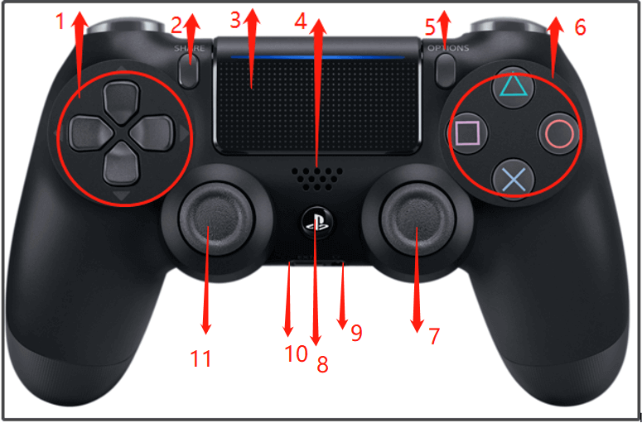

Button 15

Button 8

Button 7

Button 13

Button 14

Button 11

Button 12

Button 2

Button 0

Button 3

Button 1

R1 🡪 Button 10

L1 🡪 Button 9